Wykham Park Academy
an Aspirations Academy

Year 7
2022-2023

IMPORTANT INFORMATION
&
CONSENT FORMS

Please RETURN to school
by 24th June

Welcome to Wykham Park Academy - Sylvia Thomas, Principal

Whenever we get a new cohort of students on our campus we look forward to welcoming them into our family. Your child is joining a caring community who understands what it’s like to make the big jump to secondary school. Your children are all individuals with big dreams which we will help them work towards.

I want to say to all students joining us in September, thank you for choosing to become a member of our campus. You will always be both supported and challenged to be the very best you can be.

In this booklet you will find 7 mandatory forms to complete which are consent forms that need returning to Miss Emma Peachey at the address above at your earliest convenience please and before 24th June 2022, or, if you prefer to email your forms, send to: transition@wykhampark-aspirations.org. We are also providing a Welcome Pack with information about uniform, the school day, parents evenings and more. There is lots of information on our webpages.

It is a legal requirement that we keep parental/carer consents on our student files as well as keeping us fully informed of your child’s specific needs. Please ensure all information we ask for is included so we have complete and accurate records. There is a handy checklist at the end of the booklet to help you, including a reminder to download the School Gateway App - this includes a secure payment method for school meals, trips etc. but is also the way we will communicate with you and vice versa.
Lastly, please refer to the local authority website for information on Free home to school travel assistance for low income families.

Warm regards,
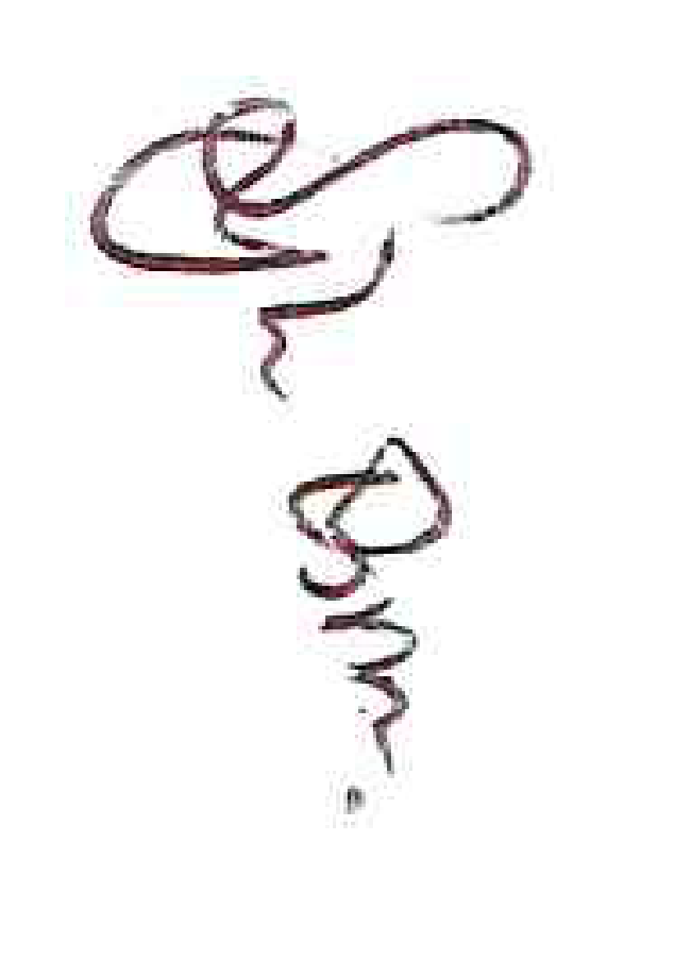

Miss Sylvia Thomas
Executive Principal of Banbury Aspirations Campus
Wykham Park Academy Year 7
Student Information Sheet - September 2022

Section 1: Details of Child:
Surname: _______________________________ Forename: _____________________
Middle name(s): __________________________ Chosen name: __________________
Previous surname (if applicable): ____________________________
Gender: Male / Female Date of Birth: __________________________
Home Address: ____________________________________________________________
_________________________________________________________________________
Postcode: __________________ Home phone number: ___________________________
(The child’s home is the permanent address where they live with their legal guardian and where any child benefit is addressed. If this is different from the parent/carer’s address, please explain why on the back of this form. Also, if parents share custody, please give both addresses and state this below; continue on the back of this form if necessary).

Does your child have any siblings who currently attend the Academy? Yes / No
If yes please give names: __________________________________________________

Section 2: Details of Parent/Carer:
Mother’s Title: ___________ Mother’s name: ____________________________________
Mother’s address: __________________________________________________________
_________________________________________________________________________
Mother’s phone no (if different from above): _____________________________________
Mother’s mobile no: _____________________ Mother’s work no: ___________________
Mother’s email address: ____________________________________________________
(It is important that you supply an email address as weekly correspondence is sent out by this method).
Do you have parental responsibility? Yes / No (please delete as appropriate)
If no please state who does: _________________________________________________

Father’s Title: ___________ Father’s name: ____________________________________
Father’s address: __________________________________________________________
_________________________________________________________________________
Father’s phone no (if different from above): _____________________________________
Father’s mobile no: _____________________ Father’s work no: ___________________
Father’s email address: ____________________________________________________
(It is important that you supply an email address as weekly correspondence is sent out by this method).
Do you have parental responsibility? Yes / No (please delete as appropriate)
If no please state who does: _________________________________________________

For Looked After Children:
Please give Social Worker’s name and contact details below:
__________________________________________________________________________
__________________________________________________________________________
Local Authority Responsible for child: ___________________________________________

Section 3: Emergency Contacts:
Please give additional names and addresses of two people who may be contacted in the event of an emergency in order of priority

Title: __________ Forename: ___________________ Surname: ____________________
Address: _________________________________________________________________
Daytime phone no: ____________________ Home phone no: _____________________
Relationship to child__________________________________

Title: __________ Forename: ___________________ Surname: ____________________
Address: _________________________________________________________________
Daytime phone no: ____________________ Home phone no: _____________________
Relationship to child__________________________________

Section 4: Medical Information:
Knowledge about children’s health is vital if we are to help them reach their potential educationally. Would you please, therefore, supply the following information about your child. This information will be available to relevant officers at the LEA, school staff and to the school health nurse.
GP’s name: ___________________________ Phone number: ______________________
Address of practice: _________________________________________________________
Has your child had his/ her pre-school booster? Yes / No / Don’t know
Does your child suffer from/have any problems with:
Mobility Behaviour Speech Vision
Hearing Bowel or bladder conditions Wears glasses
Any other medical conditions
If you have circled any of the above, please give details:
__________________________________________________________________________
__________________________________________________________________________
Does your child suffer from/have any problems with:
Serious Allergies Asthma Epilepsy Diabetes
If you have circled any of the above, please give details including if your child has a Medical Action Plan:
__________________________________________________________________________
__________________________________________________________________________
Does your child need regular medication on prescription? Yes / No
Will your child need medication during school hours? Yes / No
Does your child suffer from any condition which may affect participation in PE? Yes / No
If you have replied yes to any of the above please give details:
_____________________________________________________________________________
Section 5: Ethnic Monitoring:
Please tick the ethnic group to which your child belongs. Please note that this question is not about citizenship or nationality. It is essential that we have this information so that we can monitor the effectiveness of the school’s and the LEA’s equal opportunities policies and practices in maximising your child’s progress and achievement.

White British |  |  | Pakistani
White Irish |  |  | Bangladeshi
White Traveller of Irish heritage |  |  | Any other Asian background*
Any other white background* |  |  | Black Caribbean
White Gypsy/Roma |  |  | Black African
White and black Caribbean |  |  | Any other black background*
White and black African |  |  | Chinese
White and Asian |  |  | Any other ethnic group*
Any other mixed background* |  |  | Prefer not to answer
Indian |  |  | *(please specify):

Please state your child’s Country of Birth: ______________________________________

Please tick your child’s first language. Please tick one box only.

English |  |  | Guajarati
Punjabi |  |  | Chinese (Mandarin/Cantonese)
Urdu |  |  | Albanian
Bengali/Bangla/Sylheti |  |  | Caribbean Creole
Hindi |  |  | Other (please state):
Please tick your child’s main language (if different from above). This is the language your child speaks at home. Please tick one box only.

English |  |  | Guajarati
Punjabi |  |  | Chinese (Mandarin/Cantonese)
Urdu |  |  | Albanian
Bengali/Bangla/Sylheti |  |  | Caribbean Creole
Hindi |  |  | Other (please state):
Please tick your child’s religion, if you wish. Please tick one box only.

Christian |  |  | Jewish
Muslim |  |  | Buddhist
Hindu |  |  | Other
Sikh |  |  | No religion

Non UK applicants:

Date of entry into the UK: ______ day _____________ month ______ year

Is your child in the country now? Yes / No

Can your child speak, read and write fluent English? Yes / No

Is this the first school in the UK that your child has attended? Yes / No

Section 6: Meal Arrangements:

Free school meal |  |  | Sandwiches
Home |  |  | Paid school meal
Other
By law, children in families claiming Income Support or Income Based Jobseeker’s Allowance are entitled to free school meals (provided evidence of these benefits has been made available to the school). Even if your child will not be taking free school meals it is important that we have this information since it affects our funding and the way in which the school’s performance in tests and examinations is compared with that in other schools. We will ask this question again from time to time to ensure that our records are accurate, and on occasion may need to see relevant proof.
Section 7: Travel:
How will your child travel to the Academy? Please tick one box only.
Walks |  |  | Car
School coach |  |  | Taxi
Bicycle |  |  | Bus
Train |  |  | Other

Section 8: Previous Education:
Please give details below of the previous school attended by your child.
Name of previous school: _____________________________________________________
Address: __________________________________________________________________
Date started: _______________________ Date left: ____________________________
Name of member of staff at this school who knows your child: _________________________
Reason for change of school: __________________________________________________
__________________________________________________________________________
__________________________________________________________________________

Do you give consent for Wykham Park Academy to contact your child’s previous school prior to them starting with us? Yes / No

Please give details of your child’s school attendance (how many days missed in the past year): ____________________________________________________________________

Did your child ever receive any Fixed Term Exclusions at his/her previous school(s)?
Yes / No

If yes, please provide details:

Has your child ever received a Permanent Exclusion from any of their previous schools?
Yes / No

If yes, please provide details:

Does your child have an EHCP or has one been agreed? Yes / No

Was your child on the Special Educational Needs Register at his/her previous school?
Yes / No

If yes, please provide details:

Does your child have support in class? Yes / No

What modern foreign language(s) did your child study at his/her previous school? __________________________________________________________________________

Section 9: Signature of Parent/Carer:
Signature: ___________________________ Date: _______________________________
Name (in block capitals): _____________________________________________________
Relationship to child: ________________________________________________________

Wykham Park Academy/Futures Institute - Home School Agreement
Student Name:
The Academy - We will:
- do all we can to keep your child safe
- have high expectations of behaviour during lessons, around the academy and on the journey to and from the school site - we will enforce our behaviour and discipline policy as consistently as humanly possible
- have high expectations for uniform, jewellery and PE kit - we will enforce our uniform policy
- reward your child when they achieve in a variety of ways
- provide a broad curriculum which aims to meet the needs of all students
- encourage every student to reach his/her potential
- keep you informed about your child’s progress and general academy matters
- set and mark homework consistently
- help students to develop the skills needed to take a full and active part in life after school
- put into practice our policy for equal opportunities so that no one should suffer discrimination.

Signed _________________________________________________________ Date _______________

Student - I will:
- wear full academy uniform every day, as detailed in the uniform policy and be tidy in appearance
- behave well during lessons, around the academy and on my journey to and from school
- come to school regularly and on time
- have all equipment needed for each lesson, every day
- be helpful, respectful and polite to others
- adhere to all of the British Values which we subscribe to on the campus
- do all classwork and homework to the very best of my ability
- respect the academy buildings, grounds, furniture and equipment as well as other people’s property and belongings
- use ICT and new technologies appropriately to support my work
- keep my mobile phone turned off and in my bag during the school day whilst on campus

Signed __________________________________________________________Date______________

Parent(s)/Carer(s) - I/We will:
- ensure that my/our child wears full academy uniform, as detailed in the uniform policy and understand that he/she will be sent home to change or internally excluded if inappropriately dressed
- fully support the academy’s rewards and behaviour policy
- encourage respect for all members of the academy community
- ensure that my/our child attends school regularly (and provide a written explanation for any absence), on time and properly equipped
- not take my child out of school for holidays in term time
- let the academy know of any concerns or problems that might affect my/our child’s work or behaviour
- encourage my/our child to develop positive attitudes and achieve to the best of his/her ability
- show an interest in and support my/our child’s homework including reading with them regularly
- attend all Parents’ Evenings and other student focused events
- ensure that my/our child uses ICT appropriately to support his/her school work
- avoid phoning or texting my/our child whilst they are at school
- be responsible for the cost of repairing or replacing any school property or equipment which is purposefully damaged by my child

Signed __________________________________________________________Date______________

ICT Code
This code applies at all times, both in and out of lessons.

I understand that access to the computer network and Internet is provided to support learning. It should only be used for schoolwork. Access to the Internet, whether from a school device or using the ‘StudentNET’ with personal devices is a privilege, not a right and may be restricted or withdrawn for anyone who abuses this privilege.

I will only use my own Username and Password. I will keep my password secret and accept that I am responsible for any and all activity carried out under my username on Wykham Park Academy’s computer network.

I agree not to cause intentional damage or disruption to the school network, Learning Platform, other users’ data or to abuse the privacy of other users. I will not post personal information about myself or others on the internet.

I will respect the ICT equipment and its environment at all times. I understand I am responsible for the care of ICT equipment I am using or am allocated and will not engage in wanton vandalism of it.

I will not access websites that are inappropriate for the current lesson. I understand that non-educational games are not school work and these are not to be accessed during school hours.

I will conserve resources by only printing only that which is required for my school work. I will obtain permission before printing.

I will save my work every 10 minutes and always keep a copy of work in my own user area. In the event of a problem, it would be better to go back to the copy in your user area than to have to start again.

I will not use the school’s computer network to create or display content that may be abusive, upsetting or offensive to others.
I will not download software or inappropriate files onto the school network. This includes games, applications or music from CD ROM, MP3 players, mobile phones, the Internet or any other source
I will not install or connect anything to the school’s network which may negatively affect the operation of the system, equipment or hardware.

Be aware that staff can monitor your files and emails and can check and record anything that you do on the computer network. Users should have no expectation of privacy in their Internet traffic and computer activities.
Failure to follow the code will result in loss of access and further disciplinary action may be taken if appropriate, which could include informing your parents or the police.

Student Name: ____________________________________________ Mentor Group _______________

My parents and I have read and understood the ICT Code. I agree to follow this Code at all times and understand that privileges may be restricted or withdrawn if I do not do so.

Parent/Carer Name: …………………………………… Signature: ................................................

Student Signature: ……………………………………. Date: ………………………………………
Attendance
Important Information
for
Parents/Carers

What does ‘Good Attendance’ mean?

- 90% - Is this good attendance?
- What does 90% actually mean? Answer: 20 missed school days a year!

Research suggests that for every 17 missed school days a year = one GCSE grade drop in achievement (DfE) – the greater the attendance, the greater the potential for achievement.

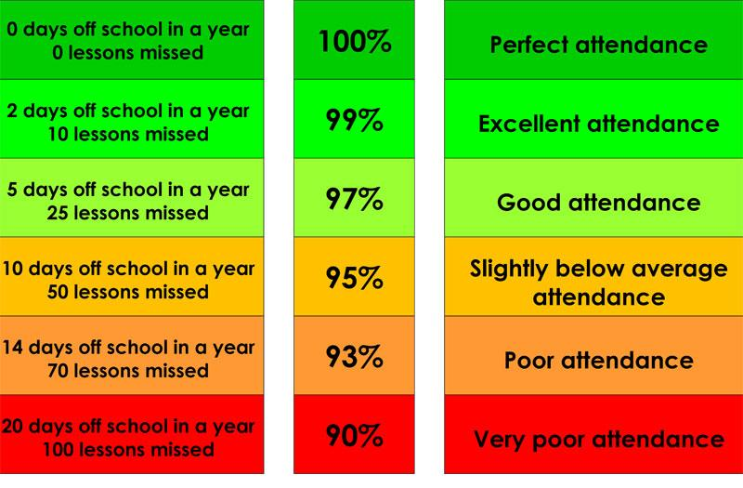

For children and young people to work towards achieving their potential, attendance needs to be 100%

Regular attendance is always associated with High Achievement.

What can you do to help?

- Wykham Park Academy and Futures Institute requires students to be in school by 8.40am to start Mentor time at 8.45am.

- If your child is absent - it is the responsibility of the parents or carers to contact us - please telephone by 8.30am on the following numbers:

Wykham Park Academy  Futures Institute | 01295 225225  01295 257942

- On the first day back after absence, send a note with your child explaining the reason for absence. This can be written in the student’s learning journal. Alternatively you can email the attendance officer at attendance@wykhampark-aspirations.org

- On 1st September 2013 a new law took effect, which does not allow parents to take their children out of school for holidays in term time. Any request for absence in term time must, in exceptional circumstances, be addressed to the Principal, who will decide whether to authorise the absence or not. Unauthorised holidays will result in Fixed Penalty Notices being issued.

- If there is a problem that is causing your child to ask you for time off, please inform the campus immediately.

- Arrange dental/doctor’s appointments out of Academy hours.

Universal expectation:
All students have a target of 100% attendance
We recognise, celebrate and reward excellent attendance

What happens if your child has too many absences?

If your child’s attendance is below the minimum expectation, you will need to come to the Academy for a School Attendance Action Meeting.

If your child’s attendance does not improve sufficiently during the monitoring period, you will need to come to the Academy for a Parent Contract Meeting.

If attendance still does not improve, a referral will be made to the County Attendance Team.

The consequence of continued poor attendance could result in a fixed penalty fine or legal action being taken, a fine of £2,500 and in the worst cases, a prison sentence.

Dear Parents/Carers

PENALTY NOTICES FOR TERM-TIME HOLIDAYS

Wykham Park Academy is committed to ensuring that your child receives the best possible education to prepare them for the next stage of their life. Each school day is carefully planned, and each lesson informs a wider programme of learning. Therefore, every lesson really does count. Your child is a valued member of our school community and every day missed is a day lost without them.

It is the policy of this school not to authorise absence for holidays during term-time. While advance permission can be given in exceptional circumstances, this is rare and can only be granted by me in my capacity as Head Teacher. Any such request should be addressed to me in writing before the holiday is taken and you should not assume that permission will be granted.

If a term-time holiday is taken without permission, the absence will be recorded as unauthorised and a referral may be made to the County Attendance Team. This may result in the issue of an Education Penalty Notice under section 444A Education Act 1996 in respect of each absent child, to each parent/carer. The current penalty is £60 per parent, per child, rising to £120 per parent per child if not paid within 21 days.

Penalty notices are intended as an alternative to prosecution. If the penalty is not paid in full within 28 days, the usual consequence is a Magistrates’ Court prosecution for the underlying section 444(1) Education Act 1996 offence of failure to secure regular school attendance. If further instances of unauthorised absence occur despite a penalty notice having previously been issued, or if the child’s attendance is a wider matter of concern, the local authority may consider prosecution in any event.

Yours sincerely
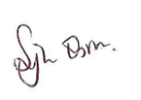
Sylvia Thomas
Executive Principal

Photograph Consent Form

This form explains the reasons why and how the Academy may use images and videos of your child. Please read the form thoroughly and outline your agreement as appropriate.

Name of pupil:
Name of parent:
Year group and class number:

Why do we need your consent?
The Academy requests the consent of parents on an annual basis to use images and videos of their child for a variety of different purposes.

Without your consent, the school will not use images and videos of your child. Similarly, if there are only certain conditions under which you would like images and videos of your child to be used, the school will abide by the conditions you outline in this form.

Why do we use images and videos of your child?
The Academy uses images and videos of pupils as part of school displays to celebrate Academy life and pupils’ achievements; to promote the Academy on social media and on the Academy’s website; and for other publicity purposes in printed publications, such as newspapers.

Where the Academy uses images of individual pupils, the name of the pupil will not be disclosed. Where an individual pupil is named in a written publication, a photograph of the pupil will not be used to accompany the text.

If, for example, a pupil has won an award and their parent would like their name to be published alongside their image, separate consent will be obtained prior to this.

The Academy may take images or videos of individual pupils and groups of pupils to use on social media, the school website, in school prospectuses and other printed publications, such as a newsletter.

Who else uses images and videos of your child?
It is common that the school is visited by local media and press, who take images or videos of school events, such as sports days. Pupils will appear in these images and videos, and these may be published in local or national newspapers, or on approved websites.
Where any organisations other than those above intend to use images or videos of your child, additional consent will be sought before any image or video is used.

What are the conditions of use?
- This consent form is valid for the current 2022/2023 academic year.
- It is the responsibility of parents to inform the Academy, in writing, if consent needs to be withdrawn or amended.
- The Academy will not use the personal details or full names of any pupil in an image or video, on our website, in our school prospectuses or any other printed publications.
- The Academy will not include personal emails or postal addresses, telephone or fax numbers on images or videos on our website, in our school prospectuses or any other printed publications.
- The Academy may use pictures of pupils and teachers that have been drawn by pupils.
- The Academy may use work created by pupils.
- The Academy may use group or class images or videos with general labels, e.g. ‘sports day’.
- The Academy will only use images and videos of pupils who are suitably dressed, i.e. it would not be suitable to display an image of a pupil in swimwear.
Providing your consent
Please read the following conditions thoroughly and provide your consent as appropriate by ticking either ‘Yes’ or ‘No’ for each criteria.

The Academy will only publish images and videos of your child for the conditions that you provide consent for.

I provide consent to: | Yes | No
Photographing and videoing my child.
Using images of my child on the Academy website.
Using videos of my child on the Academy website.
Using images of my child on the social media site, Twitter.
Using videos of my child on the social media site Instagram.
We don’t use Instagram at the moment but local media may.
Using images of my child on the social media site, Facebook.
Using images of my child on the social media site, Twitter.
The local media using images of my child to publicise school events and activities (only including the organisations outlined above).
The local media using videos of my child to publicise Academy events and activities (only including the organisations outlined above).
Using images of my child in marketing material, e.g. the Academy brochure and prospectus.
Sharing my child’s data with a school-appointed external photography company for official Academy images. This includes the following:
- Name
- Class
- Roll number

Dear Parent/Carer

Request for School to Administer Medication

For children that take prescribed medication on a daily basis, for long term or for short term illnesses and it is necessary for it to be taken during school hours, this medication will need to be handed to Student Services at the beginning of the school day in order that it can be stored appropriately. The medication has to be in the original packaging with the child’s name clearly labelled, showing the correct dosage. The school will not be able to store or administer any medication that does not fulfil the above requirements.

Wykham Park Academy will also require you to complete the Administration of Medication form on the following page before any medication is accepted by Student Services.

Yours faithfully

Miss Sylvia Thomas
Executive Principal of Banbury Aspirations Campus

Request for school to administer medication

The Academy will not give your child medicine unless it is prescribed by a GP and the GP has written to us with details of the medication; you have completed and signed this form and the Principal has agreed that Academy staff can administer the medication.

DETAILS OF STUDENT
Surname: _________________________________Date of Birth: __________ M/F: _____
Forename(s): ______________________________Tutor Group: _____________
Address: _________________________________________________________________ ___________________________________________________________________

MEDICATION
Name/Type of Medication: (as described on the container) _________________________
_______________________________________________________________________
For how long will your child take this medication? ________________________________
Date dispensed: __________________________________________________________
Full Directions for use:
Dosage and method: _______________________________________________________
Timing: _________________________________________________________________
Special Precautions: _______________________________________________________
Side Effects: _____________________________________________________________
Self-Administration: ________________________________________________________
Procedures to take in an Emergency: _________________________________________
CONTACT DETAILS
Name: _______________________________ Daytime Telephone No: _______________
Relationship to Student: ____________________________________________________
Address: ________________________________________________________________
________________________________________________________________________

I understand that I must deliver the medicine personally to [agreed member of staff] and accept that this is a service which the Academy is not obliged to undertake.

Date: __________________________Signature(s): ______________________________
Relationship to Student: ____________________________________________________

Academy Educational Visits and Off-Site Activities

Please sign the slip overleaf if you are happy for your child to:
- take part in academy trips and other activities that take place off school premises;
and
b) to be given first aid or urgent medical treatment during any academy trip or activity.

Please note the following important information before signing the form:

The trips and activities covered by this consent include all activities undertaken within the local area

Such as:
- Local sports fixtures during school hours and activities/visits outside normal school hours, where blanket consent is appropriate, such as local sports fixtures out of school hours
- Visits to local parks, libraries, museums etc.
- Regular curriculum-based adventure activities
- 14 -19 multi-site curriculum delivery
- Youth “drop-in” activity centres

Specific, (i.e. one-off), parental consent will be obtained for all other visits. For visits covered by the blanket consent, sufficient information will be made available to parents, letters, meetings, etc., so that consent is given on a ‘fully informed’ basis.

- You can, if you wish, tell the academy that you do not want your child to take part in any particular academy trip or activity.

Please complete the medical information section on the next page (if applicable) and sign and date this form if you agree to the above.

Consent to Activity, Medical Details and Treatment Form (overleaf)

Name of Young Person.................................................................... Year: ..................

Date of Birth.................................................................................... Male ☐ Female ☐

Home address: ................................................................................ Tel. No: ........................

Emergency contact telephone numbers (home/mob/work)
- ............................................ 2) ........................................ 3).....................................................

Name, address and tel. no. of own doctor ………..................................................................
................................................................................................................................................

Does he/she suffer from: asthma, chest complaints, hay fever, migraine, fits or faints, bad period pains, travel sickness, diabetes, attention deficiency, hyper activity or any other condition, illness or disability? If so, please give details: ………...............................................................………………………………... …………………………………………………………………………………………………………………….

Is he/she allergic to anything? (E.g. aspirin, antibiotics, any particular food or drug? If so, give details) ………………………………………......................................................................
…………………………………………………………………………………………………………

Is he/she having any medical treatment at present? If so, please give written details of treatment and medicines, etc. (These MUST be handed to the Party Leader) ………………
..……………………………………………………………………………………………………..…

Are there any reasons that you know of that stops her/him from participating fully in the planned
activities? ................................................................................................................................
................................................................................................................................................

Are there any activities in which he/she should not participate? …………..............................
………………………………………………………………………………………………………….

Date of anti-tetanus injection (if known)...................................................................................

Is there any other relevant information which the party Leader should be aware of? ..............
..................................................................................................................................................

Please indicate any special food dietary/requirements where applicable: ..............................
.................................................................................................................................................

I wish my child to take part in the journey/activities and having read the information provided, agree to his/her taking part in any or all of the activities described. Yes ☐ No ☐

Name (Please print)………………….……………… Signature………………….……………… Date………………
* All journeys and activities carry some amount of risk.

CONSENT TO MEDICAL TREATMENT

I …………………………….. (YOUR NAME IN BLOCK CAPITALS PLEASE) agree to my son/daughter receiving any emergency or other medical treatment as deemed urgent, necessary and/or in the best interest of my son/daughter by the medical authorities present. This includes dental, medical or surgical treatment, the use of anaesthetics or blood transfusion.

I also agree to the release of relevant and necessary medical information to educational establishment staff by the GP if circumstances are deemed necessary and appropriate.

Name (Please print)………………….……………… Signature………………….………………

Date………………

Dear Parent/Carer

Re: Young Carers Project

At Wykham Park Academy and Futures Institute we are committed to supporting all our students and we often find that the more we know about our students the easier it is to ensure they receive the correct kind of support. Therefore knowing if our students have caring responsibilities at home, due to parental or sibling disability or long-term illness enables us to put in place extra systems to monitor them and ensure that their education is not adversely affected.

If you feel that your child has caring responsibilities within the home, we would be grateful if you could let us know, so that we can work with you to ensure the best outcomes for your child. Obviously any information you share with us will be kept confidential and only shared with other agencies with your permission.

Should you wish to discuss this, please contact me and I will be happy to offer further support, guidance and clarification.

Yours sincerely
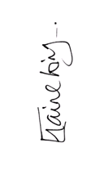
Elaine King
Welfare Manager (Ext 221)

We want to make sure that we are providing your child with the best education and support we can. Healthy school food has obvious health benefits and can help pupils establish healthy habits for life. Healthy school food can also help to improve pupils’ readiness to learn.
Families who receive certain benefits may be eligible for free school meals.
Your child is eligible for free school meals if you’re in receipt of one of the following benefits:
- Universal Credit with an annual net earned income of no more than £7,400.
- Income Support
- Income-based Jobseeker’s Allowance
- Income-related Employment and Support Allowance
- Support under Part 6 of the Immigration and Asylum Act 1999
- The guarantee element of Pension Credit
- Working Tax Credit run-on (paid for the four weeks after you stop qualifying for Working Tax Credit)
- Child Tax Credit (with no Working Tax Credit) with an annual income of no more than £16,190
- Registering for free meals could also raise an extra £900 for our child’s school, to fund valuable support like extra tuition, additional teaching staff or after school activities.
- This additional money is available from central government for every child whose parent is receiving one of the benefits listed above.
- To check if your child is eligible, we need information about you and your child. Please complete the form overleaf and return to Student Services.
Yours faithfully

Lisa Palmer
Student Services
Ext: 230

APPLICATION FOR FREE SCHOOL MEALS
ABOUT YOUR CHILD/CHILDREN
Child’s Last Name | Child’s First Name | Child’s Date of Birth |  |  | Name of School
 |  | D D | M M | Y Y Y Y
 |  | D D | M M | Y Y Y Y
 |  | D D | M M | Y Y Y Y
PARENT/GUARDIAN DETAILS
 | Parent/Guardian 1 |  |  |  |  |  |  |  |  |  |  |  |  |  |  |  |  |  |  |  | Parent/Guardian 2
Last name
First Name
Date of Birth | D D |  |  |  |  |  | M M |  |  |  |  |  | Y Y Y Y |  |  |  |  |  |  |  | D D |  |  |  |  |  | M M |  |  |  |  |  |  | Y Y Y Y
National Insurance Number*
National Asylum Support Service (NASS) Number* |  |  |  | / |  |  |  |  |  |  | / |  |  |  |  |  |  |  |  |  |  |  |  | / |  |  |  |  |  |  | /
Daytime Telephone Number
Mobile Number
Address | Postcode: |  |  |  |  |  |  |  |  |  |  |  |  |  |  |  |  |  |  |  | Postcode:

FAMILY INCOME AND BENEFIT DETAILS

If you receive any of the benefits listed below, please place an X in this box.
- Income Support
- Income-based Jobseekers Allowance
- Income-related Employment and Support Allowance
- Support under part 6 of the Immigration and Asylum Act 1999
- The guarantee element of Pension Credit
- Child Tax Credit (with no Working Tax Credit) with an annual income of no more than £16,190
- Working Tax Credit run-on (paid for the four weeks after you stop qualifying for Working Tax Credit.
- Universal Credit with an annual net earned income of no more than £7,400
Universal Credit
If you are in receipt of Universal Credit, is your net earned family income over £7,400 per year? (Please place an X in the appropriate box).
Your net earned income is your household income after taxes and deductions. It does not include income through Universal Credit or other benefits that you may receive.

Yes No Unsure

Child Tax Credit
If you are in receipt of Child Tax Credit, is your joint gross annual income over £16,190 per year? (Please place an X in the appropriate box).
Your joint gross income is your household income before taxes are taken into account.

Yes No Unsure
If you’re not sure whether you receive one of the listed benefits, or what your household income is, but you would still like us to check whether your child is eligible for free school meals, please place an X in this box.
DECLARATION
The information I have given on this form is complete and accurate. I understand that my personal information is held securely and will be used only for local authority purposes. I agree to the local authority using this information to process my application for free school meals. I also agree to notify the local authority in writing of any change in my family’s financial circumstances as set out in this form.
Signature of parent/guardian: ………………………………………………Date:…………………..
Thank you for completing this form and helping to make sure your child’s school is as well funded as possible.

How the information in this form will be used

The information you provide in this form will be used by the council to confirm receipt of one of the listed welfare benefits. Once this is confirmed, this helps to decide how much money your child’s school will receive each year. The information will also be used in relation to pupils in year 3 or above to decide whether they are eligible for free school meals.

You only need to complete this form once and it will last for the duration of your child’s time at their current school. You should contact the school or local authority if you have a change in financial circumstances.

We are committed to ensuring that the personal and sensitive information that we hold about you is protected and kept safe and secure, and we have measures in place to prevent the loss, misuse or alteration of your personal information. We will use the information you provide to assess entitlement to free school meals. The information may also be shared with other Council departments to offer benefits and services.

PERMISSION AGREEMENTS CHECKLIST

DOCUMENT NAME | DOCUMENTS SIGNED
WP ACADEMY/FUTURES STUDENT ADMISSION & INFORMATION FORM

HOME/ACADEMY AGREEMENT

ICT CODE

PHOTOGRAPH PERMISSION

REQUEST TO ADMINISTER MEDICATION

ACADEMY EDUCATIONAL VISITS AND OFF-SITE ACTIVITIES

CONSENT TO ACTIVITY MEDICAL AND TREATMENT FORM

APPLICATION FOR FREE SCHOOL MEALS

Have signed up for School Comms/School Gateway (see next page)

PLEASE RETURN THESE DOCUMENTS TO SCHOOL
To transitions@wykhampark-aspirations.org
By Friday 24th June 2022 at the latest.

&

Communication between School & Home
+ Payment method for School Meals etc.

Wykham Park Academy’s preferred choice of contacting parents/carers is by text, email* or telephone. It is therefore important that you notify us of any changes to your contact details.

*If you do not have access to email or text it is important that you let us know this. We can then ensure that you receive paper copies of any letters or communications to you about your child concerning events such as parents’ evenings, trips, workshops etc. and will ensure your child does not miss out on opportunities and events during the school year.

At ANY TIME changes to contact details should be directed to Student Services by emailing them: ktibbetts-reeves@wykhampark-aspirations.org or lpalmer@wykhampark-aspirations.org

If you do not have access to email, please telephone Student Services on 01295 251451 ext 249 or 230 to inform them of any changes. Alternatively, your child can obtain a “Change of Contact Details” form as seen overleaf and return to Student Services, so they are able to update our records.

In order to enable two-way communication between you and the school, you need to download the SchoolGateway App. To help you get signed up click here. It is really IMPORTANT you use the primary email address and phone number that you provide the school or the app won’t work.

- Download the Android or iPhone app.

- Press ‘Sign Up’ then enter the email and mobile number your school has on record. If you’re not sure if they have the right details, it’s best to check and update first.

Cashless payments

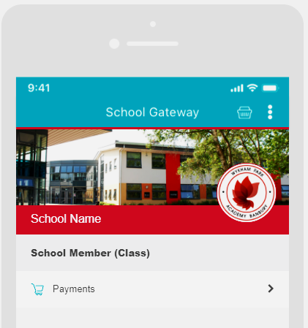
Wykham Park Academy uses the School Gateway payments service to enable you to use School Gateway to pay for school dinners, clubs, trips, uniform and more.

This means you won’t have to queue up at the school office or send your children into school with cash envelopes to pay for trips.

You can use credit/debit cards, Bank Transfer or PayPoint from more than 28,000 shops.

Track your payment history and receive either digital or printed receipts from your school.

Notes

……………………………………………………………………………………………………………………………………………………………………………………
……………………………………………………………………………………………………………………………………………………………………………………
……………………………………………………………………………………………………………………………………………………………………………………
……………………………………………………………………………………………………………………………………………………………………………………
……………………………………………………………………………………………………………………………………………………………………………………
……………………………………………………………………………………………………………………………………………………………………………………
……………………………………………………………………………………………………………………………………………………………………………………
……………………………………………………………………………………………………………………………………………………………………………………
……………………………………………………………………………………………………………………………………………………………………………………
……………………………………………………………………………………………………………………………………………………………………………………
……………………………………………………………………………………………………………………………………………………………………………………
……………………………………………………………………………………………………………………………………………………………………………………
……………………………………………………………………………………………………………………………………………………………………………………

